
Connect the dots by following your ABCs
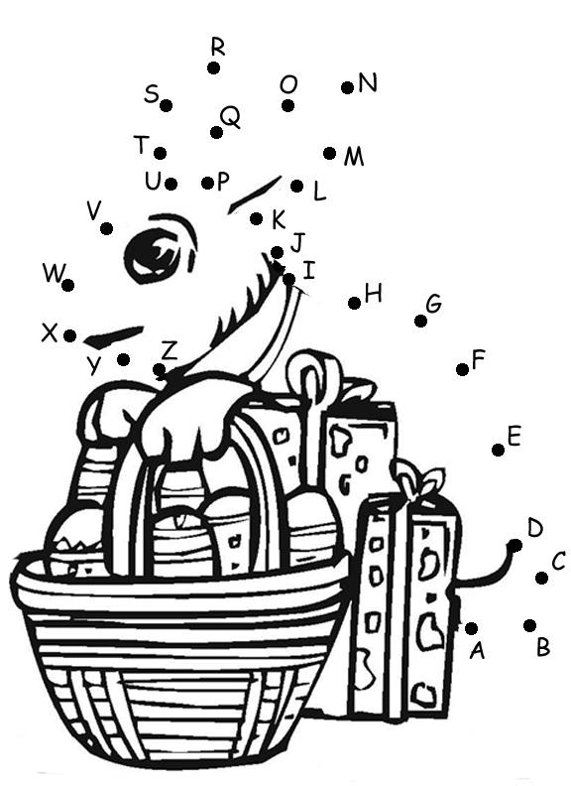

© 2005 www.bogglesworld.com

