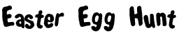
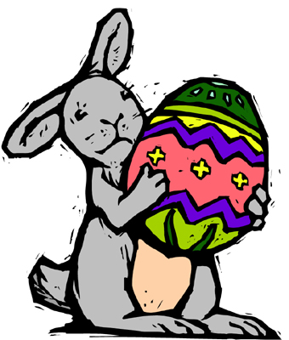
 |  | How many words can you make out of EASTER EGG HUNT?
 |  | E A S T E R E G G H U N T
 |  |  | ___________ |  |  |  |  | ___________
 |  |  | ___________ |  |  |  |  | ___________
 |  |  | ___________ |  |  |  |  | ___________
 |  |  | ___________ |  |  |  |  | ___________
 |  |  | ___________ |  |  |  |  | ___________
 |  |  | ___________ |  |  |  |  | ___________
 |  |  | ___________ |  |  |  |  | ___________
 |  |  | ___________ |  |  |  |  | ___________
 |  |  | ___________ |  |  |  |  | ___________
 |  |  | ___________ |  |  |  |  | ___________
 |  |  | ___________ |  |  |  |  | ___________

Did you find?
 | A color. |  |  | The opposite of this.
 | A number. |  |  | The opposite of here.
 | A planet. |  |  | The opposite of those.
 | A weapon. |  |  | The opposite of messy.
 | A rodent. |  |  | The opposite of love.
 | Something you drink. |  |  | The opposite of west.
 | Something you wear. |  |  | The opening in a fence.
 | What you chew with. |  |  | Very, very good!
 | What a squirrel eats. |  |  | Another word for begin.
 | A game kids play. |  |  | Another word for country.
Difficult: | A place to act. |  |  | Three of your senses.
 | A place to drive. |  |  | A verb, both past and present.
 | Dirty old torn clothes. |  |  | To look at for a long time.

