
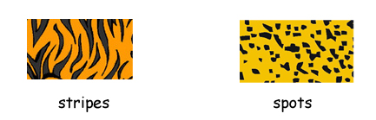
What color are tigers?
 | 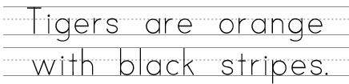
What color are leopards?
 | 
What color are zebras?
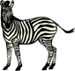
What color are cows?
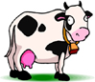

What color are clown fish?

What color are ladybugs?
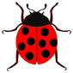
What color are Dalmatians?

What color are bees?

Can you think of any animals with stripes or spots?
Stripes |  | Spots

