
Connect the dots by following your ABCs
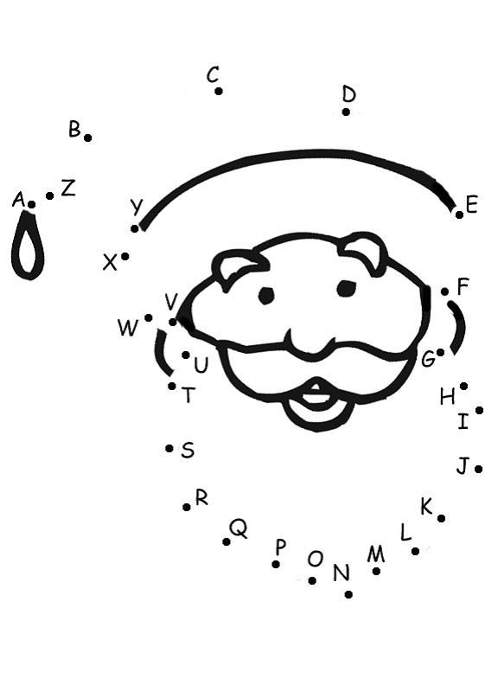
© 2004 www.bogglesworld.com

