
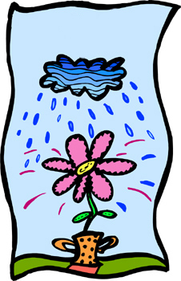
 |  | How many words can you make out of APRIL SHOWERS?
 |  | A P R I L S H O W E R S
 |  |  | ___________ |  |  |  |  | ___________
 |  |  | ___________ |  |  |  |  | ___________
 |  |  | ___________ |  |  |  |  | ___________
 |  |  | ___________ |  |  |  |  | ___________
 |  |  | ___________ |  |  |  |  | ___________
 |  |  | ___________ |  |  |  |  | ___________
 |  |  | ___________ |  |  |  |  | ___________
 |  |  | ___________ |  |  |  |  | ___________
 |  |  | ___________ |  |  |  |  | ___________
 |  |  | ___________ |  |  |  |  | ___________
 |  |  | ___________ |  |  |  |  | ___________

Did you find?
 | A fruit.
 | An oyster’s treasure.
 | A shovel’s friend.
 | Another word for clean.
 | Say something bad.
 | Something that travels the ocean.
 | Something to tie things up with.
 | The opposite of better.
 | The opposite of dull.
 | The opposite of peace
 | What you wear on your feet.
Difficult: | Two question words.
 | A verb both past and present.
 | The place where sea meets land.

April showers bring May flowers.

www.bogglesworld.com

