
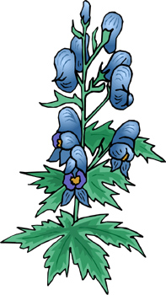
 |  | How many words can you make out of THE BUDS OF MAY?
 |  | T H E B U D S O F M A Y
 |  |  | ___________ |  |  |  |  | ___________
 |  |  | ___________ |  |  |  |  | ___________
 |  |  | ___________ |  |  |  |  | ___________
 |  |  | ___________ |  |  |  |  | ___________
 |  |  | ___________ |  |  |  |  | ___________
 |  |  | ___________ |  |  |  |  | ___________
 |  |  | ___________ |  |  |  |  | ___________
 |  |  | ___________ |  |  |  |  | ___________
 |  |  | ___________ |  |  |  |  | ___________
 |  |  | ___________ |  |  |  |  | ___________
 |  |  | ___________ |  |  |  |  | ___________

Did you find?
 | Something you drink.
 | Something you wear.
 | A ship under water.
 | The opposite of hard.
 | The opposite of no.
 | The opposite of night.
 | The opposite of love.
 | The place where you live.
 | A place where you sit.
 | The past tense of sit.
 | The month and the day.
Difficult: | Another word for add.
 | Two emotions.
 | A round roof.

www.bogglesworld.com

