
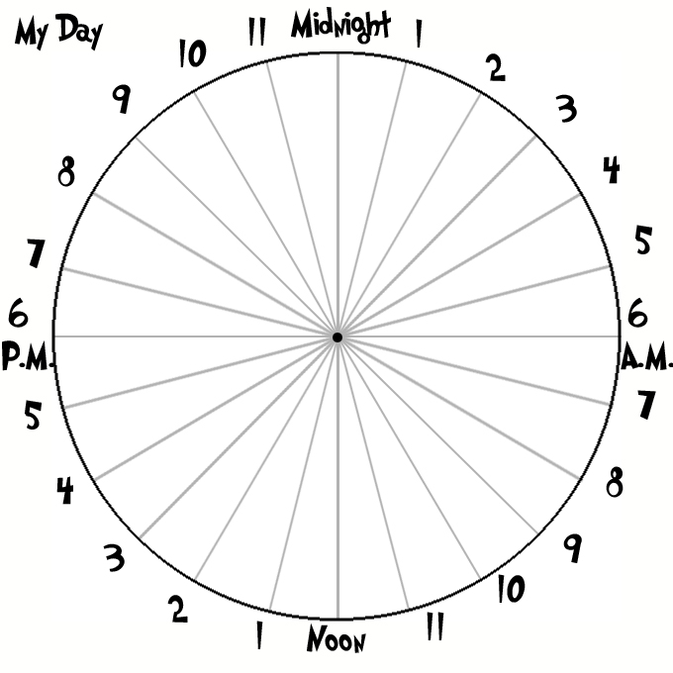
What do you do during the day? Write down 6 things you do and when you do them. Fill in the day circle above:
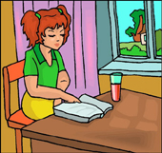
 | What do you do? | From | To
www.bogglesworld.com

