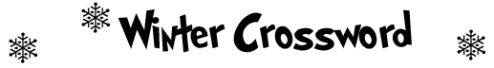

 |  | Across  3. This hangs from your roof.  5. This covers your window.  7. This covers the ground.  8. These keep your hands warm and dry.  10. A winter activity on ice.  12. First month of winter.  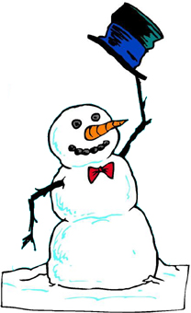 |  |  |  | 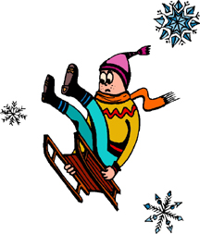

Down
1. ______ degrees Celsius: Freezing.
2. Wear this to keep warm.
4. These keep your feet dry.
6. You can ride this.
9. Winter weather.
11. This covers ponds and lakes.
www.bogglesworld.com

