
What hangs from the roof and rhymes with bicycle?  What’s a small piece of snow that rhymes with cake?  What do you do that rhymes with me?  What do you wear that rhyme with loves? |  | 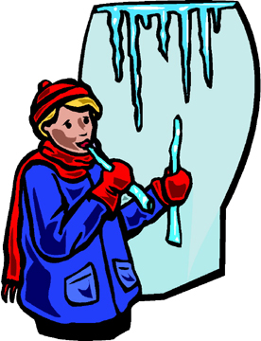
What falls from the sky and rhymes with glow?

What covers your window and rhymes with lost?

What’s a winter month that rhymes with remember?

What do you fight with that rhymes with hall?

What do you do that rhymes with wait?

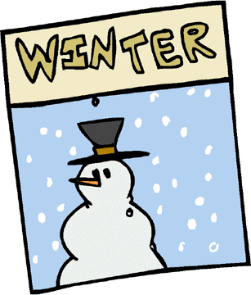 | What another word for snowstorm that rhymes with lizard?  What makes you warm that rhymes with hire?  What do you skate on that rhymes with nice?
(c) 2002 www.bogglesworld.com

