
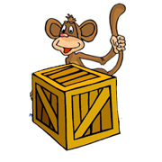 | behind  The monkey is behind the box.
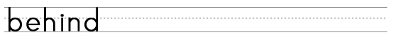
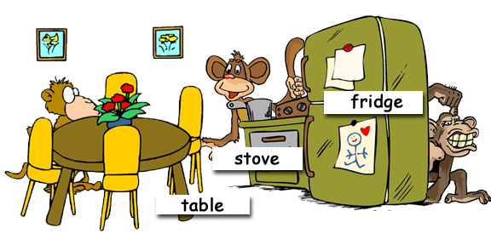

Where are the monkeys?
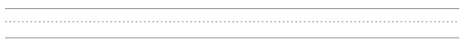
www.bogglesworld.com

