
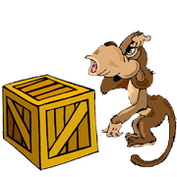 | next to  The monkey is next to the box.
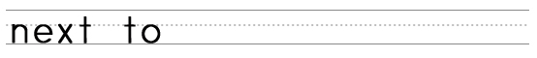
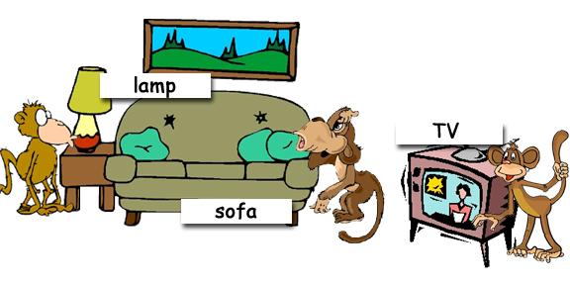

Where are the monkeys?
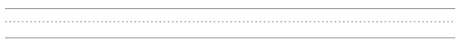
www.bogglesworld.com

