
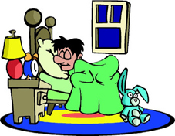 | When do you sleep?  I sleep from 11:30 P.M. to 7 A.M.
When do you sleep?
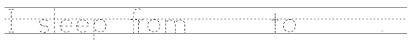
When do you have lunch?

When do you go to school?
When do you do homework?
When do you watch TV?
When do you exercise?
When do you eat dinner?
www.bogglesworld.com

