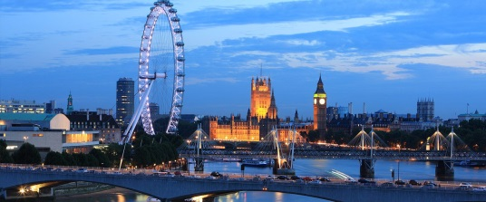
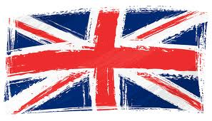
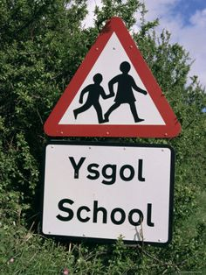
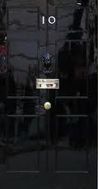
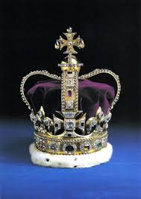
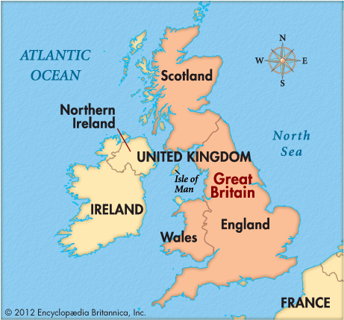
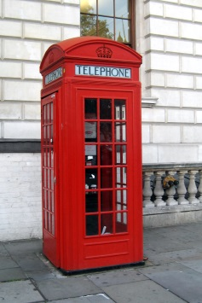
Britain Quiz
How much do you know about Britain? Work in groups and answer these questions.
- The sport people watch most in Britain is:
- cricket b) football c) tennis d) rugby
- What is the traditional Sunday Lunch?
- fried eggs and bacon b) roast meat c) fish and chips d) a Cornish pasty
- What is the name of the highest mountain in Britain?
- Snowdon b) Scafell Pike c) Ben Nevis

- The capital of Northern Ireland is:
- Cardiff b) Dublin c) Belfast d) Edinburgh
- How many countries are in the U.K?
a) 1 b) 5 c) 4 d) 2
- What is the second largest city in the UK?
- Birmingham b) Cardiff c) Plymouth d) Brighton
- Which country in Britain has road signs written in two languages:
- Wales b) England c) Scotland
- 10 Downing Street is the home of:
- Harry Potter b) Theresa May c) Prince William
d) David Beckham
- Who is the patron saint of England?
- St David b) St George c) St Patrick d) St Andrew
- Who was born in Stratford-upon-Avon?
- Charles Dickens b) Princess Diana c) William Shakespeare d) Winston Churchill
- The Queen’s granddaughter Zara Philips is a famous Olympic:
a) horse rider b) swimmer c) boxer d) hockey player

- Where are the crown jewels kept?
- Buckingham Palace b) The Tower of London
c) Westminster Abbey d) Big Ben
- The most expensive shop in Britain is:
- Marks and Spencer’s b) Harrods c) Macys d) Primark
- What is an MP?
- a military policeman b) a Member of Parliament c) a Prime-Minister
- Which political party is currently in government in 2017?
- The Labour Party b) UKIP c) The Conservative Party d) The Liberal Democrats?

- You can drive in Britain when you are:
- 16 b) 17 c) 21 d) 18
- To buy alcohol in a pub you have to be:
a) 14 b) 21 c) 18 d) 16
- You can get married in Britain when you are:
- 14 b) 16 c) 18 d) 21
- You can leave school in Britain when you are:
- 15 b) 16 c) 18 d) 19

- Match these words to their meanings.
- a quid a) a cup of tea
- a cuppa b) a short sleep
- a telly c) an umbrella
- a loo d) £1
- a brolly e) a television
- a kip f) a toilet

- Match the places to the reason they are famous:

- Wimbledon a) a famous football pitch
- Cambridge b) tennis
- Wembley Stadium c) horse racing
- Ascot d) the home of Sherlock Holmes
- Baker Street e) an international music festival
- Glastonbury f) an old university town
Answers:
- The sport people watch most in Britain is:
- cricket b) football c) tennis d) rugby
- What is the traditional Sunday Lunch?
- fried eggs and bacon b) roast meat c) fish and chips d) a Cornish pasty
- What is the name of the highest mountain in Britain?
- Snowdon b) Scafell Pike c) Ben Nevis
- The capital of Northern Ireland is:
- Cardiff b) Dublin c) Belfast d) Edinburgh
- How many countries are in the U.K?
a) 1 b) 5 c) 4 d) 2
- What is the second largest city in the UK?
- Birmingham b) Cardiff c) Plymouth d) Brighton
- Which country in Britain has road signs written in two languages:
- Wales b) England c) Scotland
- 10 Downing Street is the home of:
- Harry Potter b) Theresa May c) Prince William
d) David Beckham
- Who is the patron saint of England?
- St David b) St George c) St Patrick d) St Andrew
- Who was born in Stratford-upon-Avon?
- Charles Dickens b) Princess Diana c) William Shakespeare d) Winston Churchill
- The Queen’s granddaughter Zara Philips is a famous Olympic:
a) horse rider b) swimmer c) boxer d) hockey player
- Where are the crown jewels kept?
- Buckingham Palace b) The Tower of London
c) Westminster Abbey d) Big Ben
- The most expensive shop in Britain is:
- Marks and Spencer’s b) Harrods c) Macys d) Primark
- What is an MP?
- a military policeman b) a Member of Parliament c) a Prime-Minister
- Which political party is currently in government in 2017?
- The Labour Party b) UKIP c) The Conservative Party d) The Liberal Democrats?
- You can drive in Britain when you are:
- 16 b) 17 c) 21 d) 18
- To buy alcohol in a pub you have to be:
a) 14 b) 21 c) 18 d) 16
- You can get married in Britain when you are:
- 14 b) 16 c) 18 d) 21
- You can leave school in Britain when you are:
- 15 b) 16 c) 18 d) 19

- Match these words to their meanings.

- a quid- D a) a cup of tea
- a cuppa- A b) a short sleep
- a telly- E c) an umbrella
- a loo- F d) £1
- a brolly- C e) a television
- a kip- B f) a toilet

- Match the places to the reason they are famous:

- Wimbledon- B a) a famous football pitch
- Cambridge- F b) tennis
- Wembley Stadium-A c) horse racing
- Ascot- C d) the home of Sherlock Holmes
- Baker Street- D e) an international music festival
- Glastonbury- E f) an old university town

