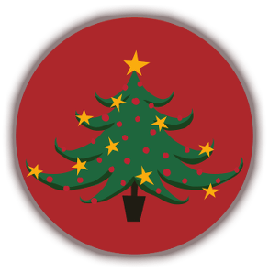

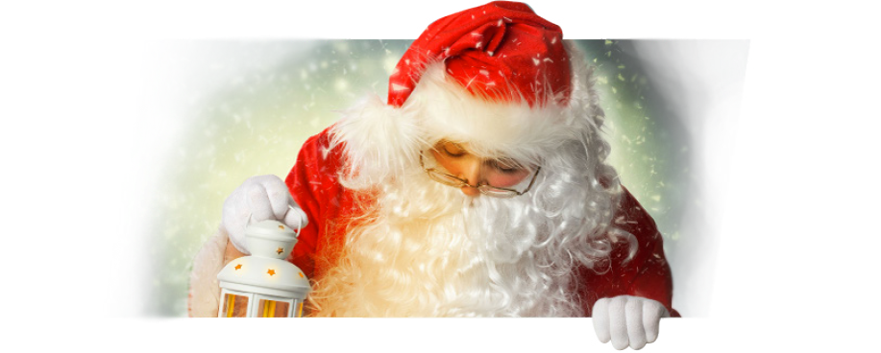

Listen and fill in. https://english-portal.com.ua/worksheet/christmas-traditions#topadv
December 1 ____________! And children begin to get 2 ____________ because of Christmas. About two thousand years ago, Jesus was born in the town of Bethlehem. At Christmas, people 3 ______________ that special time. Today, Christmas is a very 4 ________________ time in the Christian year, but it is also very important to people who do not go to church. It is a time for presents, parties, and tie with the family.
People start to get ready for Christmas in late October or early November. They decorate their shops with lights, trees, and other decorations. Shops get very busy and stay open 5 _____________.
In the middle of December, most families buy Christmas trees, put them inside the house, and put colourful decorations on them. They also send cards to friends and family. The cards say things like “Merry Christmas and a Happy New Year” or “Seasons Greeting”.
Many children 6 _______________ about the baby Jesus at school. Sometimes they do a play about the story and sing Christmas songs, called carols, for their mothers and fathers. A lot of schools have parties for the children, and many 7 _____________ have parties at work in December. Most people do not have to work on 25 and 26 in December, and many have a week’s holiday, from 25 December to 1 January. They usually spend this time at home with their family, or perhaps they visit friends or family who live far away.
The Christmas holiday begins on 24 December: Christmas eve. People often stop 8 ____________ early and have a drink together, or finish their Christmas shopping. They put special paper on the presents and leave them under the tree. Children leave a stocking for Santa Claus (called Father Christmas in Britain) when they go to bed. Santa is a big man with white hair and red clothes who brings presents for children during the night. Mothers and fathers tell their children that Santa only comes when they are sleeping. They also tell them that Santa leaves presents for good children- but for bad children only leaves a piece of black coal! The children are 9 _____________, of course, so often they do not sleep very well. Some children leave a drink and a mince pie for Santa and some vegetables for his animals.
Many people go to 10 ____________ at midnight on Christmas Eve. They listen to Christmas story and sing carols. Next morning it is Christmas Day 25 December. Children usually wake up very early. They look in their stockings to see presents that Santa put there for them. After 11 _____________ they open their other presents around the tree.
Christmas dinner is in the afternoon and is the biggest meal of the day. Before they start to eat, people pull crackers. The crackers make a loud noise, and have a small game and a hat 12 ________________. Dinner is usually turkey with lots of winter vegetables and then a Christmas pudding. Often there are hot mince pies too.
26 December is called Boxing Day. It is a holiday for many people, but a lot of shops open on this day. In the nineteenth century, rich people gave 13 _____________ of presents to their workers on Boxing Day. Now people enjoy eating, drinking, and watching television at home, or going out to watch some sport.
Another British Christmas tradition is the pantomime. A pantomime is a kind of 14 ______________ with a children’s story (like Cinderella or Aladdin) and lots of music and songs. There is usually a 15 ____________ who wears women’s clothes and plays an old woman. “She” is not very beautiful, but she is usually very funny. Children like pantomimes because they can laugh, sing, shout, and make lots of noise. They often go with their school or family.
The Christmas season ends on the twelfth day after 25 December, which is 6 January.
Read the text and choose the correct answer.
1.What do people celebrate at Christmas?
- Santa’s birthday.
- St Nicholas’s birthday.
- Jesus’s birthday.
2.Christmas is a very important time …
- Only for Christians
- For all people
- For children
3.When do people start to get ready
for Christmas?
- In autumn
- In winter
4.What do children do at school
before Christmas?
- do plays about Jesus
- sing Christmas carols
- have parties
- all of the mentioned above
5.What do people usually do during
their Christmas holidays?
- Have parties at work
- Visit their families
- Spend time alone
6.What does Santa leave for bad children?
- A piece of paper
- A piece of cake
- A piece of coal

7.Why do children wake up early
on Christmas Day?
- To wrap the presents
- To open the presents
- To eat Christmas breakfast
8.A Christmas Cracker is
- a Christmas dessert
- a cardboard paper tube
- a Christmas present
9.Rich people gave boxes of presents
to their workers
- on Boxing Day
- on Christmas Day
- on Christmas Eve
10.A pantomime is
- a play
- a film
- a song
- a game

Christmas Speaking Skills
Christmas Listening activities
Christmas Jeopardy
Christmas trivia

Watch the video and answer the questions.
https://www.youtube.com/watch?v=C1f9OOLSERA&t=1s
Do you celebrate Christmas in your country?
Is Christmas a national holiday in your country?
What’s the weather like at Christmas in your country?
What do you usually eat at Christmas?
Do you put up a Christmas tree? What decorations do you put on it?
What Christmas events do you have at school/work?
Who brings presents to children in your country?
Do people go to church at Christmas in your country?
How long is your Christmas holiday?

