Fun Facts About England | British Culture

Warm-Up Questions
Ask your teacher and classmates the following questions.

1. What do you know about England?

2. Have you ever been to England?

3. Who are some famous people from England?
MATCHING - Match the words on the left with the meanings on the right.

- sake (n) | - the feeling of being slightly angry or irritated
- attract (v) | - very famous or popular
- iconic (adj) | - the quality that allows someone to do things that are dangerous or frightening
- reigning (adj) | - to cause something to come toward someone or something
- steeped in (phr) | - an occasion when two or more people communicate with each other
- interaction (n) | - usual, common, normal
- remedy (n or v) | - to depart and move or travel in a particular direction
- annoyance (n) | - occupying the throne; ruling
- accompany (v) | - to cure, relieve or heal
- standard (adj) | - to have a lot of a particular quality or thing
- head down to (idiom) | 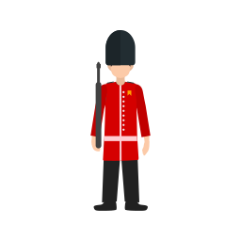  - for the purpose of
- bravery (n)  Trivia: True or False – If false, what is true? | - to go along with someone or something

1. T | F England shares borders with Scotland and Ireland.

2. T | F Cheese rolling is a sport in England.

3. T | F The national dish is Fish and Chips.



Listening Questions

Watch the YouTube video and answer the following questions.
1
Compare England and Japan.
2
7
5
What is the most famous tradition in England?
Where is England and what is it part of?
8
3
6
4
What aren’t the English particularly famous for?
What is England’s national animal and when/how is it often used?
What sports are popular in England?
What inventions originated in England?
What is the capital city of England and what are some famous landmarks there?

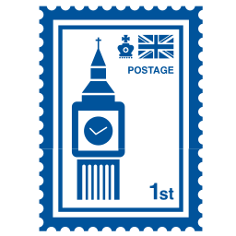
Discussion Questions

Discuss the following questions with your teacher and classmates.

1. What famous landmarks do you know in England?

2. Have you ever eaten a British breakfast? (Google it if not)

3. Do you like football (soccer)?

4. Compare England and your country? How are they similar or different?

5. Are you interested in the Royal family?

6. England is known for its bad weather. Compare it to the weather in your country.

7. Who are some famous people from England? Describe them.

8. Are you interested in British history?

9. Would you like to live in England? Why or why not?

10. Do you think British pronunciation is easy or difficult to understand? Why?



Watch the video and answer the questions.
https://youtu.be/MEXT4b7rP8o

