
Reading: Culture and gifts

Read this information about giving gifts in various countries
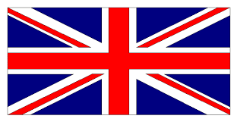

UK
Business acquaintances do not exchange gifts at Christmas, but usually send each other Christmas cards. People usually give a small gift such as a bottle of wine, flowers, or chocolates if they are invited to someone’s home.

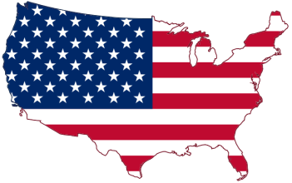

USA

An employee who is retiring, getting married or having a child will usually receive gifts from their colleagues. In some multinational companies, there are strict policies in place about giving or receiving gifts at work.

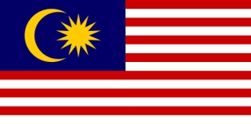
Malaysia
Gifts are not given unless a relationship with the person has been established. Gifts that may be misinterpreted as a bribe are unwelcome

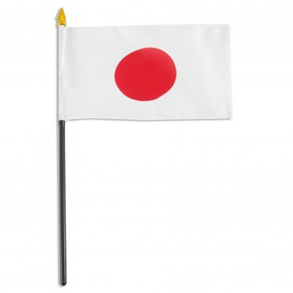

Japan
Giving gifts is an important social act. An employee usually brings back inexpensive gifts for colleagues after a vacation. In business and daily lift, gifts are not opened in the presence of the giver. If you receive a wrapped gift, set it aside until the giver leaves.

- Work with a partner or in small groups. Discuss these questions:
1. Which country above has a similar custom of giving gifts as in VietNam
2. Do you ever give gifts to clients/customers/ your boss? If yes, on what occasion do you do so?
3. Is gift-giving an important part of doing business? Why or Why not?
4. Is it OK for clients to receive expensive gifts from a company?
4. What kind of gifts would you take and accept if you were a foreigner to Vietnam on a business trip?

